For this project default bamboo directory is /export/bamboo/xml-data/build-dir/SAM-AN-AN

I have installed ansible in this bamboo server, ansible installation path is /usr/bin/ansible

**#ansible –version** output will show the executable location of ansible**.**

[root@anbuserver]# ansible --version

ansible 2.7.9

config file = /export/bamboo/xml-data/build-dir/SAM-AN-AN/ansible.cfg

configured module search path = [u'/root/.ansible/plugins/modules', u'/usr/sha

re/ansible/plugins/modules']

ansible python module location = /usr/lib/python2.6/site-packages/ansible

**executable location = /usr/bin/ansible**

python version = 2.6.6 (r266:84292, Jun 11 2019, 11:01:44) [GCC 4.4.7 20120313

(Red Hat 4.4.7-23)]

Then we have add capablity on this bamboo console as below.

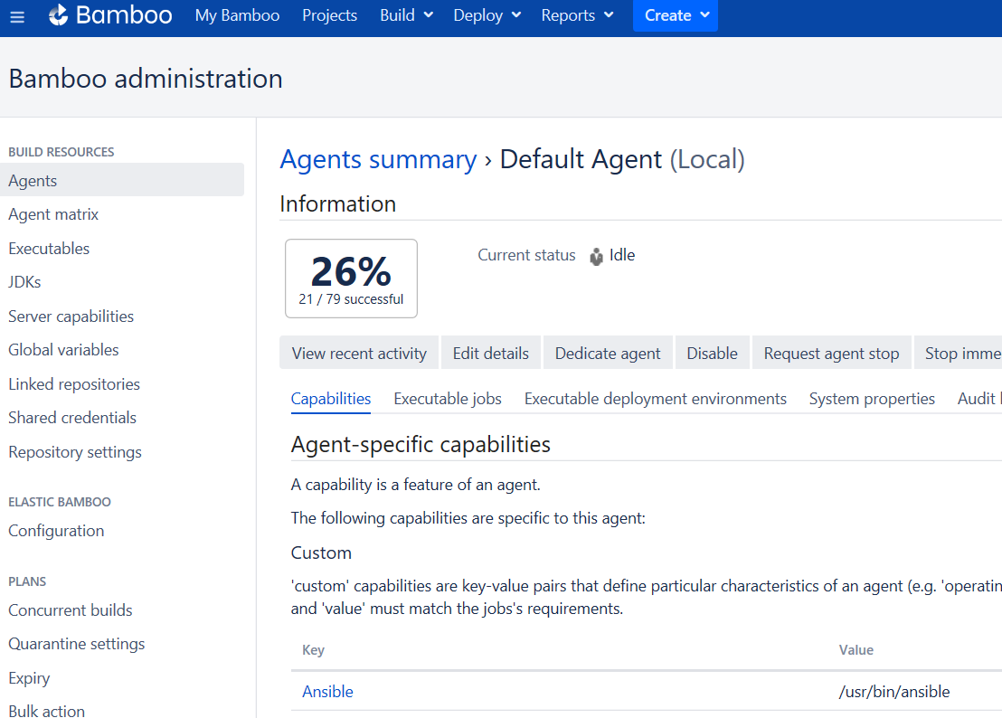

First we have to create build plan on bamboo

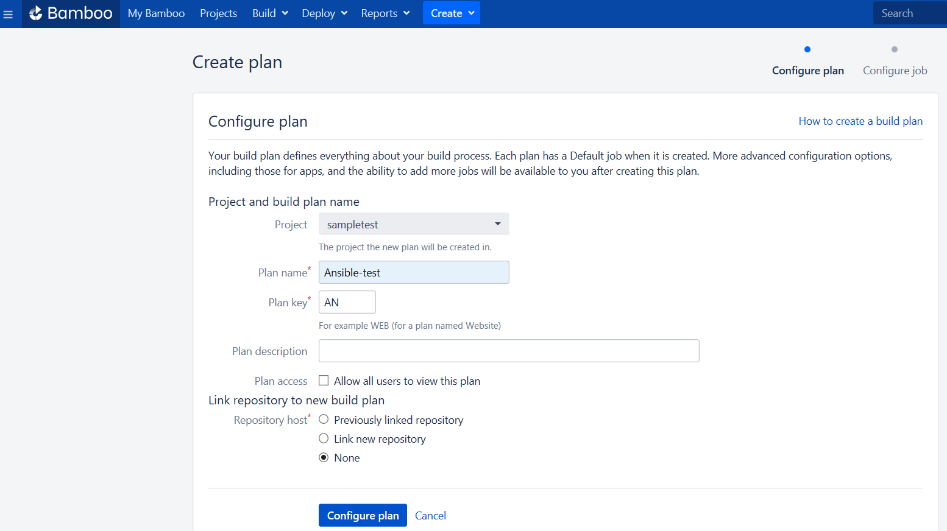

Once we configured plan from existing project name ‘sampletest’, plan will be created below name as Ansible-Test.

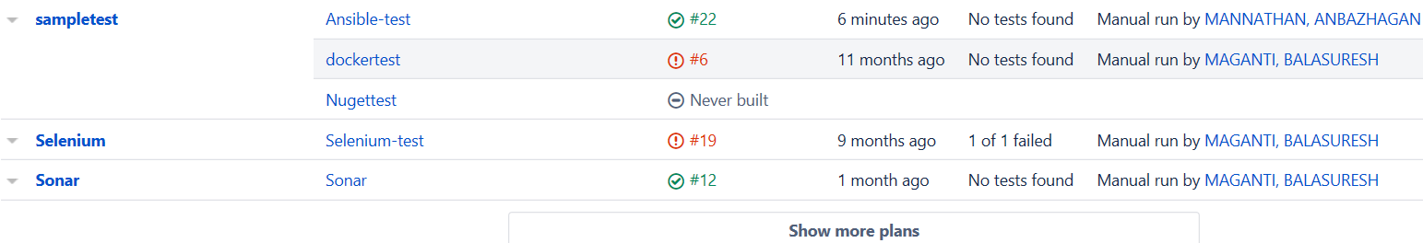

I have to configure plan for Ansible-test .

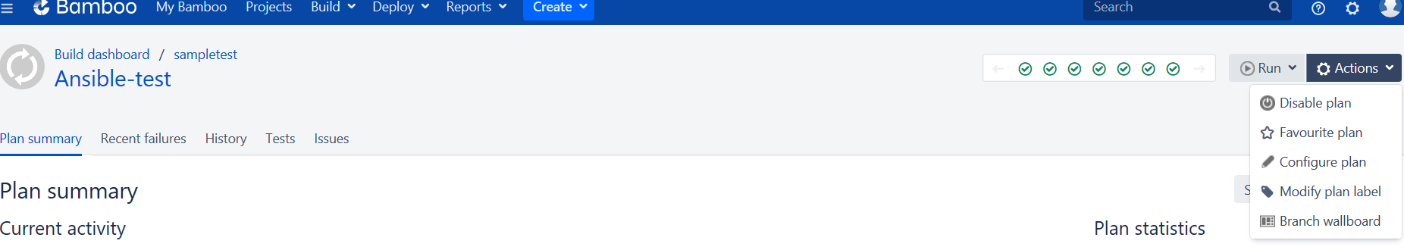

Click configure plan option from right side, and click Ansible job.

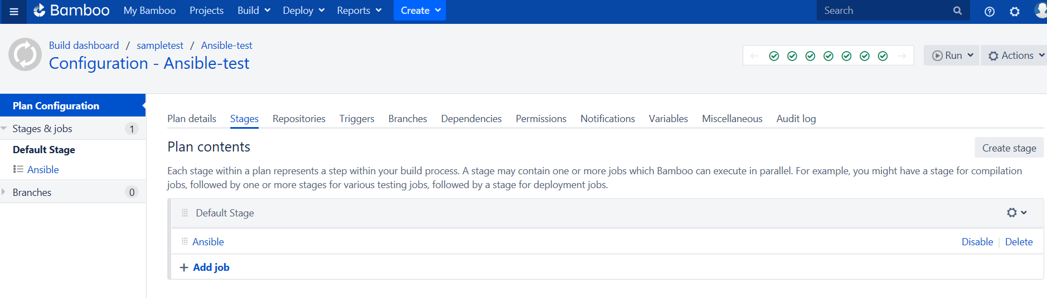

Now we have add the task for ansible job , so I choose script task option.

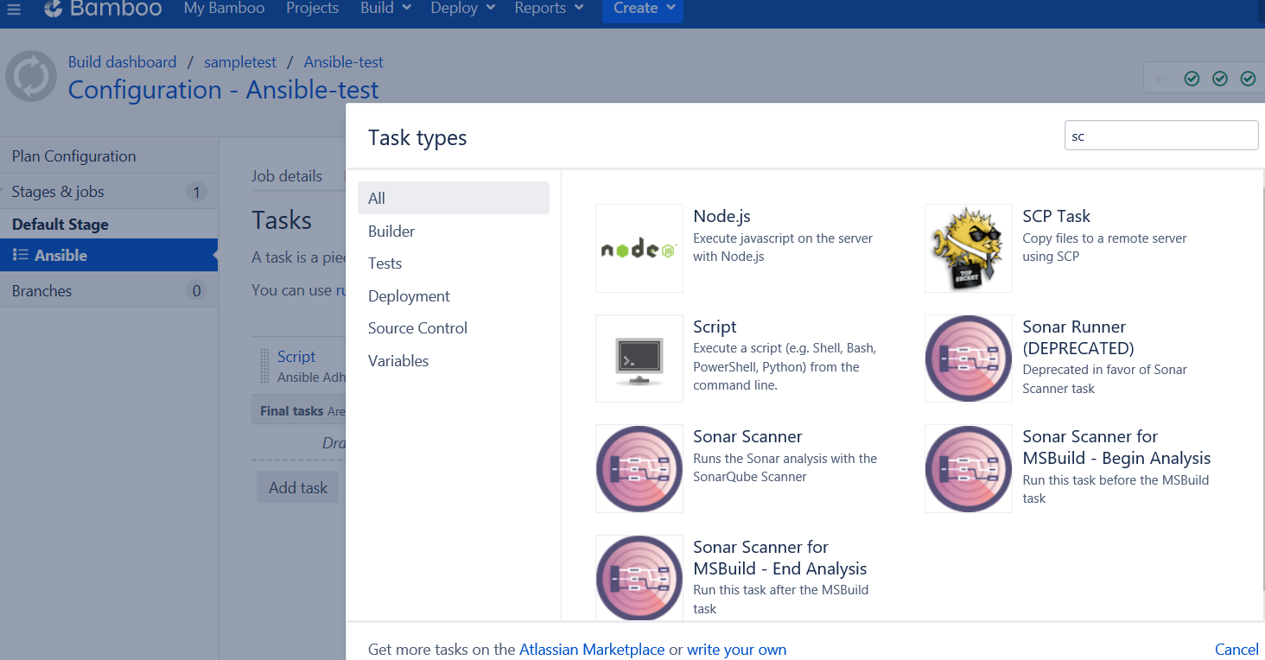

We have to configure script option for ansible as it is below, then save the task.

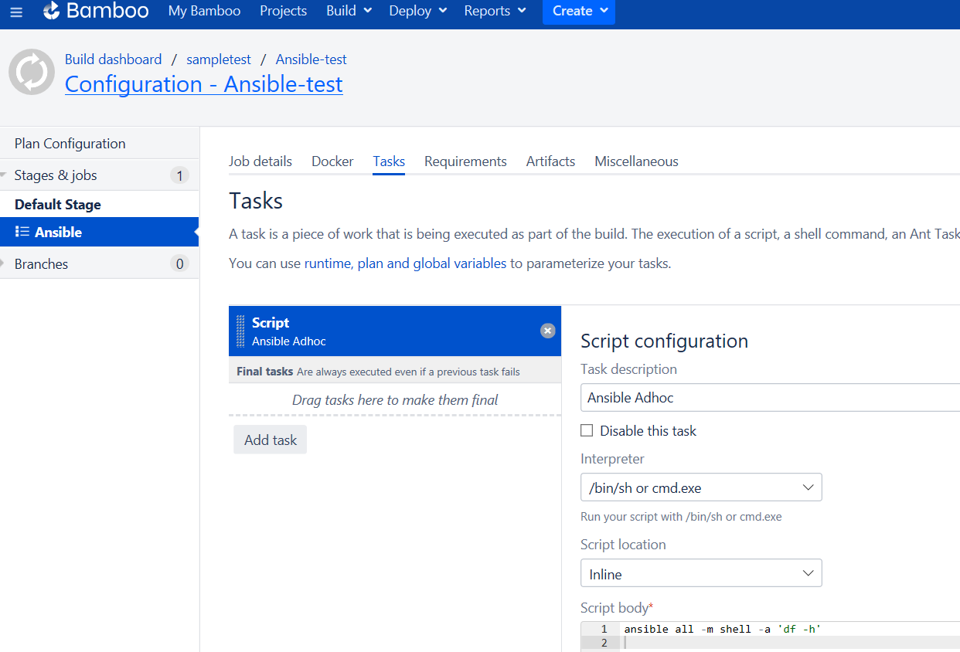

**For this project default bamboo build directory is /export/bamboo/xml-data/build-dir/SAM-AN**

**So I put ansible.cfg and inventory files on above path.**

(Red Hat 4.4.7-23)]

[root@anbuserver] cat ansible.cfg

[defaults]

host_key_checking=False

remote_user=anbu

inventory=**/export/bamboo/xml-data/build-dir/SAM-AN**

timeout=60

[privilege_escalation]

become=True

inventory files will have list of IP address

[root@anbuserver]# ls -ltr

total 8

-rw-r--r-- 1 root root 1161 Jul 19 16:10 inventory

-rw-r--r-- 1 root root 149 Jul 19 16:10 ansible.cfg

------------------------------------------------------------------------

**Once you run the build , you will see the output via log tab**

